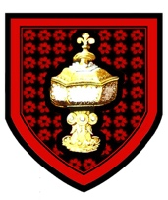
St Mary Magdalene Parish Church, Lincoln

HARVEST FESTIVAL
Sunday 27th September

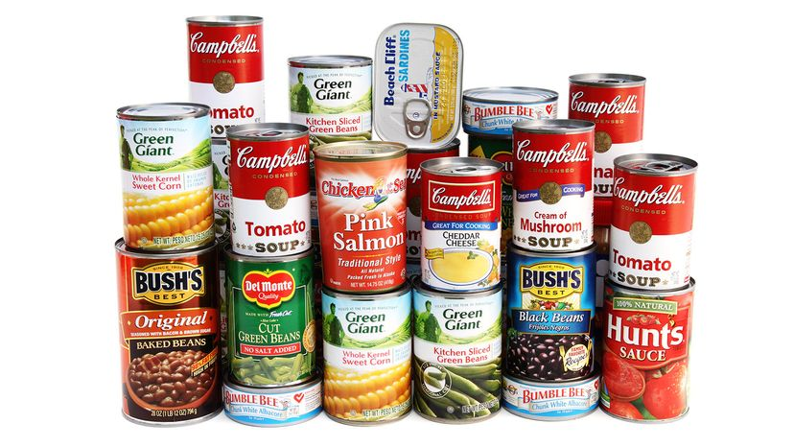

Choral Eucharist for Harvest
11.00 am
Followed by a Bring and Share lunch

Choral Evening Prayer
6.00 pm
Harvest Gifts of tinned food will be donated to
Lincoln Community Grocery Shop
These may be brought to St Mary’s next Sunday or left in
church during daily Church Opening

