Lincoln St Mary Magdalene
with St Paul in the Bail & St Michael on the Mount
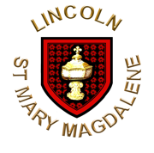

The Liturgy of the Feast of Pentecost
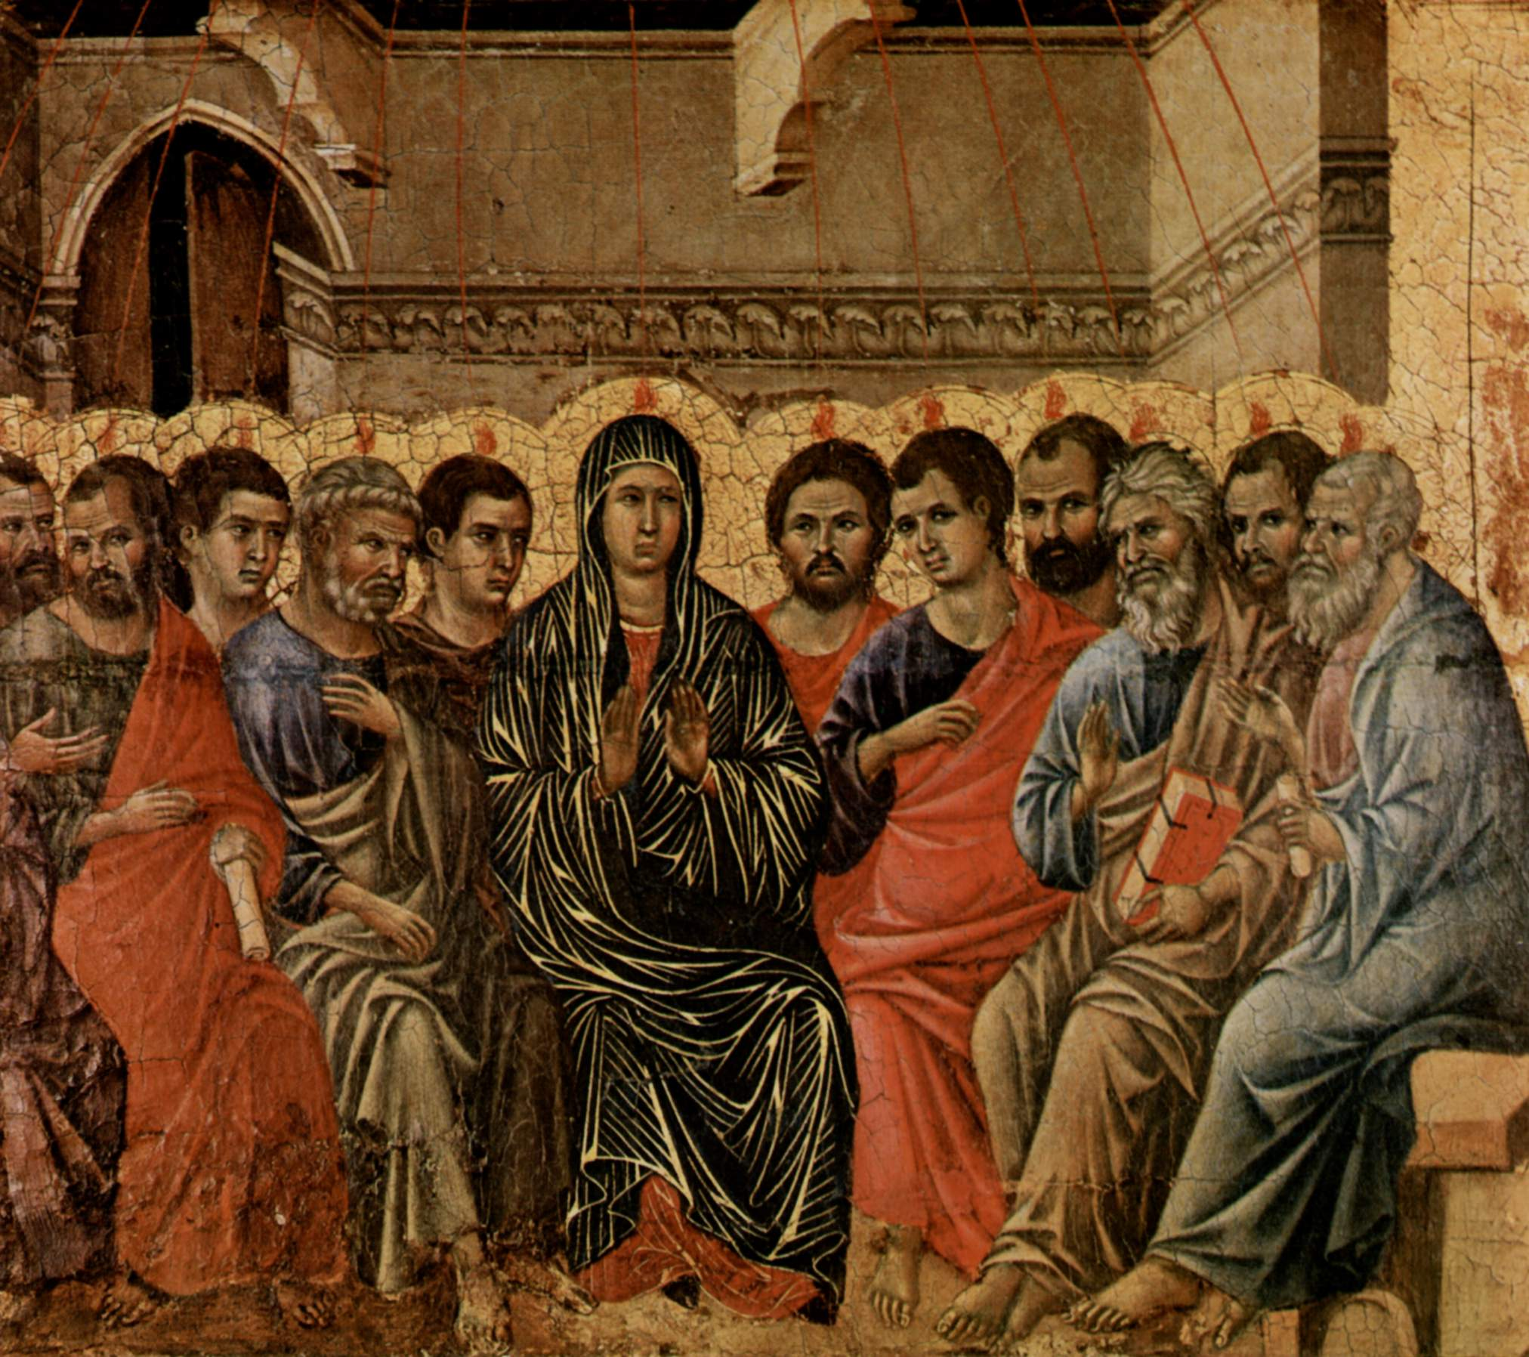
Duccio di Buoninsegna (1308) - Public Domain
About this Service
The Feast of Pentecost is a celebration of the gift of God’s Holy Spirit. It comes at the end both of the fifty day celebration of Easter, and of the yearly re-telling of the story of salvation that begins on Advent Sunday.
The gift of God’s Holy Spirit establishes the Church, and empowers it to fulfil the mission entrusted to it by the risen Christ. Pentecost is therefore also a celebration of the Church, now the body of Christ in the world, animated with his risen life by the Spirit of God.
All of these themes are reflected in this service, in which Easter responses are used for the last time in the year. Our prayer to be continually renewed by the Holy Spirit runs throughout.
Please feel free to join in with the service as you feel most comfortable. All are welcome at the altar. If you would prefer not to take the sacrament, but would like to receive a blessing, please keep your hands at your sides, or crossed across your chest.
The Gathering
At the entry of the ministers a hymn is sung.
The president says
In the name of the Father,
and of the Son,
and of the Holy Spirit.
All Amen.
The Greeting
The president greets the people
Grace, mercy and peace
from God our Father
and the Lord Jesus Christ be with you.
All And also with you.
Alleluia. Christ is risen.
All He is risen indeed. Alleluia.
Introduction
The president introduces the service
Jesus Christ, whom we worship, is our crucified,
risen and ascended Lord
and we have walked with him through his journey of love.
We have faced the agony of his suffering and death on a cross.
We have rejoiced at his bursting free from the bonds of death.
We have enjoyed his risen presence with us
and his revelation of himself through the breaking of bread.
We have seen his return to the throne before which
every knee shall bow
and every tongue confess that this Jesus is Lord.
And now, with the followers of his own time,
we await the coming of the promised Holy Spirit, his gift to his people,
through whom we make Christ known to the world.
Responsory
As we wait in silence,
All fill us with your Spirit.
As we listen to your word,
All fill us with your Spirit.
As we worship you in majesty,
All fill us with your Spirit.
As we long for your refreshing,
All fill us with your Spirit.
As we long for your renewing,
All fill us with your Spirit.
As we long for your equipping,
All fill us with your Spirit.
As we long for your empowering,
All fill us with your Spirit.
Silence is kept.
The Pentecost Reading
Acts 2.1-13
When the day of Pentecost had come, they were all together in one place. And suddenly from heaven there came a sound like the rush of a violent wind, and it filled the entire house where they were sitting. Divided tongues, as of fire, appeared among them, and a tongue rested on each of them. All of them were filled with the Holy Spirit and began to speak in other languages, as the Spirit gave them ability. Now there were devout Jews from every nation under heaven living in Jerusalem. And at this sound the crowd gathered and was bewildered, because each one heard them speaking in the native language of each. Amazed and astonished, they asked, ‘Are not all these who are speaking Galileans? And how is it that we hear, each of us, in our own native language? Parthians, Medes, Elamites, and residents of Mesopotamia, Judea and Cappadocia, Pontus and Asia, Phrygia and Pamphylia, Egypt and the parts of Libya belonging to Cyrene, and visitors from Rome, both Jews and proselytes, Cretans and Arabs – in our own languages we hear them speaking about God’s deeds of power.’ All were amazed and perplexed, saying to one another, ‘What does this mean?’ But others sneered and said, ‘They are filled with new wine.’
The reader says
The Lord is here.
All His Spirit is with us.
Prayer for Personal Renewal
Oil is brought forward, the bearer saying
Oil for the renewal of God’s people.
The president says
Be with us, Spirit of God;
All nothing can separate us from your love.
Breathe on us, breath of God;
All fill us with your saving power.
Speak in us, wisdom of God;
All bring strength, healing, and peace.
Those who wish to receive this ministry of prayer come forward. A hymn is sung
When the prayer is ended the president says
Let us bless the Father, and the Son, and the Holy Spirit.
All Let us praise and bless God for ever.
Gloria in Excelsis
Gloria in excelsis is said or sung in this or another form
All Glory to God in the highest,
and peace to his people on earth.
Lord God, heavenly King,
almighty God and Father,
we worship you, we give you thanks,
we praise you for your glory.
Lord Jesus Christ, only Son of the Father,
Lord God, Lamb of God,
you take away the sin of the world:
have mercy on us;
you are seated at the right hand of the Father:
receive our prayer.
For you alone are the Holy One,
you alone are the Lord,
you alone are the Most High, Jesus Christ,
with the Holy Spirit,
in the glory of God the Father.
Amen.
The Collect
The president introduces a period of silent prayer with these words
Let us pray that the Spirit will work through our lives
to bring Christ to the world.
Silence is kept, then the Collect is said
God, who as at this time
taught the hearts of your faithful people
by sending to them the light of your Holy Spirit:
grant us by the same Spirit
to have a right judgement in all things
and evermore to rejoice in his holy comfort;
through the merits of Christ Jesus our Saviour,
who is alive and reigns with you,
in the unity of the Holy Spirit,
one God, now and for ever.
All Amen.
The Liturgy of the Word
Reading
At the end the reader says
This is the word of the Lord.
All Thanks be to God.
A Psalm is sung and the following Canticle is said
Canticle
Ezekiel 36:24-26,28b
Response: The Spirit of God fills the whole world. Alleluia.
1 I will take you from the nations, ♦
and gather you from all the countries.
2 I will sprinkle clean water upon you, ♦
and you shall be clean from all your uncleannesses.
3 A new heart I will give you, ♦
and put a new spirit within you,
4 And I will remove from your body the heart of stone ♦
and give you a heart of flesh.
5 You shall be my people, ♦
and I will be your God.
Response: The Spirit of God fills the whole world. Alleluia.
Gospel Reading
This acclamation heralds the Gospel reading
Alleluia, alleluia.
Come, Holy Spirit, fill the hearts of your faithful people
and kindle in them the fire of your love.
All Alleluia.
When the Gospel is announced the reader says
Hear the Gospel of our Lord Jesus Christ according to N.
All Glory to you, O Lord.
At the end
This is the Gospel of the Lord.
All Praise to you, O Christ.
Sermon
The Creed
All We believe in one God,
the Father, the Almighty,
maker of heaven and earth,
of all that is,
seen and unseen.
We believe in one Lord, Jesus Christ,
the only Son of God,
eternally begotten of the Father,
God from God, Light from Light,
true God from true God,
begotten, not made,
of one Being with the Father;
through him all things were made.
For us and for our salvation he came down from heaven,
was incarnate from the Holy Spirit and the Virgin Mary
and was made man.
For our sake he was crucified under Pontius Pilate;
he suffered death and was buried.
On the third day he rose again
in accordance with the Scriptures;
he ascended into heaven
and is seated at the right hand of the Father.
He will come again in glory to judge the living and the dead,
and his kingdom will have no end.
We believe in the Holy Spirit,
the Lord, the giver of life,
who proceeds from the Father and the Son,
who with the Father and the Son is worshipped and glorified,
who has spoken through the prophets.
We believe in one holy catholic and apostolic Church.
We acknowledge one baptism for the forgiveness of sins.
We look for the resurrection of the dead,
and the life of the world to come.
Amen.
Prayers of Intercession
This response is used
Lord, come to bless us
All and fill us with your Spirit.
And at the end
in your mercy fill us with your Spirit,
All hear our prayer,
and make us one in heart and mind
to serve you with joy for ever. Amen.
The Liturgy of the Sacrament
The Peace
The president introduces the Peace
God has made us one in Christ.
He has set his seal upon us and, as a pledge of what is to come,
has given the Spirit to dwell in our hearts. Alleluia.
The peace of the Lord be always with you
All and also with you.
Let us offer one another a sign of peace.
All may exchange a sign of peace.
Preparation of the Table
Taking of the Bread and Wine
A hymn is sung. The gifts of the people are gathered and presented. The altar is prepared and bread and wine are placed upon it. This prayer is said
Blessed be God,
who feeds the hungry,
who raises the poor,
who fills our praise.
All Blessed be God for ever.
The Eucharistic Prayer
The Lord be with you (or) The Lord is here.
All and also with you. His Spirit is with us.
Lift up your hearts.
All We lift them to the Lord.
Let us give thanks to the Lord our God.
All It is right to give thanks and praise.
It is indeed right, it is our duty and our joy,
always and everywhere to give you thanks,
holy Father, almighty and everlasting God,
through Jesus Christ, your only Son our Lord.
This day we give you thanks
because in fulfilment of your promise
you pour out your Spirit upon us,
filling us with your gifts, leading us into all truth,
and uniting peoples of many tongues in the confession of one faith.
Your Spirit gives us grace to call you Father,
to proclaim your gospel to all nations
and to serve you as a royal priesthood.
Therefore we join our voices with angels and archangels,
and with all those in whom the Spirit dwells,
to proclaim the glory of your name,
for ever praising you and saying:
Sanctus and Benedictus are said or sung in this or another form
All Holy, holy, holy Lord,
God of power and might,
heaven and earth are full of your glory.
Hosanna in the highest.
Blessed is he who comes in the name of the Lord.
Hosanna in the highest.
The president recalls the Last Supper. This acclamation may be used
Praise to you, Lord Jesus:
All Dying you destroyed our death,
rising you restored our life:
Lord Jesus, come in glory.
The Prayer continues and leads into the doxology, to which all respond boldly
All Amen.
The Lord’s Prayer
Being made one by the power of the Spirit,
let us pray with confidence as our Saviour has taught us
All Our Father, who art in heaven,
hallowed be thy name;
thy kingdom come;
thy will be done;
on earth as it is in heaven.
Give us this day our daily bread.
And forgive us our trespasses,
as we forgive those who trespass against us.
And lead us not into temptation;
but deliver us from evil.
For thine is the kingdom,
the power and the glory,
for ever and ever.
Amen.
Breaking of the Bread
The president breaks the consecrated bread.
We break this bread
to share in the body of Christ.
All Though we are many, we are one body,
because we all share in one bread.
Agnus Dei is said or sung in this or another form
Lamb of God,
you take away the sin of the world,
have mercy on us.
Lamb of God,
you take away the sin of the world,
have mercy on us.
Lamb of God,
you take away the sin of the world,
grant us peace.
Giving of Communion
The president says
Alleluia. Christ our passover is sacrificed for us.
All Therefore let us keep the feast. Alleluia.
The president and people receive communion. During the distribution anthems are sung
Prayer after Communion
Silence is kept.
This prayer is said
Faithful God,
who fulfilled the promises of Easter
by sending us your Holy Spirit
and opening to every race and nation
the way of life eternal:
open our lips by your Spirit,
that every tongue may tell of your glory;
through Jesus Christ our Lord.
All Amen.
The President says the Post Communion prayer, then we pray together
All Father of all,
we give you thanks and praise,
that when we were still far off
you met us in your Son and brought us home.
Dying and living, he declared your love,
gave us grace, and opened the gate of glory.
May we who share Christ’s body live his risen life;
we who drink his cup bring life to others;
we whom the Spirit lights give light to the world.
Keep us firm in the hope you have set before us,
so we and all your children shall be free,
and the whole earth live to praise your name;
through Christ our Lord.
Amen.
The Dismissal
The ministers go to the Easter Candle
Blessing of Light
A minister says
Blessed are you, sovereign God, overflowing in love.
With Pentecost dawns the age of the Spirit.
Now the flame of heaven rests on every believer.
Strong and weak, women and men tell out your word;
the young receive visions, the old receive dreams.
With the new wine of the Spirit
they proclaim your reign of love.
Amid the birth pangs of the new creation
the way of light is made known.
Source of freedom, giver of life,
blessed are you, Father, Son and Holy Spirit.
All Blessed be God for ever.
Each member of the congregation has a candle. A hymn is sung as the candles are lit. When all the candles are lit the president says
Commission
For fifty days we have celebrated the victory of our Lord Jesus Christ over the powers of sin and death. We have proclaimed God’s mighty acts and we have prayed that the power that was at work when God raised Jesus from the dead might be at work in us.
As part of God’s Church here in the City and Diocese of Lincoln, I call upon you to live out what you proclaim.
Empowered by the Holy Spirit, will you dare to walk into God’s future, trusting him to be your guide?
All By the Spirit’s power, we will.
Will you dare to embrace each other and grow together in love?
All We will.
Will you dare to share your riches in common and minister to each other in need?
All We will.
Will you dare to pray for each other until your hearts beat with the longings of God?
All We will.
Will you dare to carry the light of Christ into the world’s dark places?
All We will.
Conclusion
The president says
The Lord is here.
All His Spirit is with us.
Today we have remembered the coming of God’s power on the disciples and we invite that same Spirit to drive us out into the wild places of the world.
The president blesses the people, saying
May the Spirit,
who hovered over the waters when the world was created,
breathe into you the life he gives.
All Amen.
May the Spirit,
who overshadowed the Virgin when the eternal Son came among us,
make you joyful in the service of the Lord.
All Amen.
May the Spirit,
who set the Church on fire upon the Day of Pentecost,
bring the world alive with the love of the risen Christ.
All Amen.
And the blessing of God almighty,
the Father, the Son, and the Holy Spirit,
be among you and remain with you always.
All Amen.
A minister says
Filled with the Spirit’s power,
go in the light and peace of Christ. Alleluia, alleluia.
All Thanks be to God. Alleluia, alleluia.

Common Worship: Services and Prayers for the Church of England, material from which is included in this service, is copyright © The Archbishops’ Council 2000.

Common Worship: Times and Seasons, material from which is included in this service, is copyright © The Archbishops’ Council 2006.

