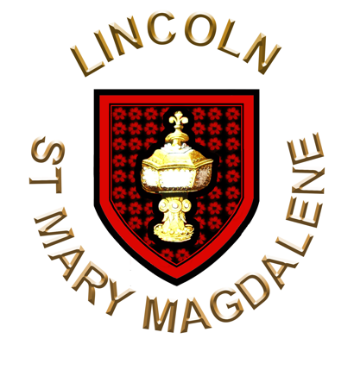
Lincoln St Mary Magdalene
with St Paul in the Bail & St Michael on the Mount

Patronal Festival Eucharist

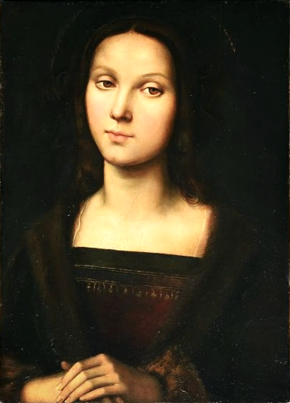
St Mary Magdalene, 1505, attr. Raphael

The Gathering
At the entry of the ministers this hymn is sung.
Love Divine, All Loves Excelling
Love divine, all loves excelling,
joy of heaven, to earth come down,
fix in us thy humble dwelling,
all thy faithful mercies crown.
Jesu, thou art all compassion,
pure unbounded love thou art;
visit us with thy salvation,
enter every trembling heart.
Come, almighty, to deliver,
let us all thy grace receive;
suddenly return, and never,
never more thy temples leave.
Thee we would be always blessing,
serve thee as thy hosts above;
pray, and praise thee without ceasing,
glory in thy perfect love.
Finish then thy new creation,
pure and spotless let us be;
let us see thy great salvation
perfectly restored in thee.
Changed from glory into glory,
till in heaven we take our place,
till we cast our crowns before thee,
lost in wonder, love and praise.
Words: Charles Wesley (1707-1788)
Music: Blaenwern; William Penfro Rowlands (1860-1937)
The president says
In the name of the Father,
and of the Son,
and of the Holy Spirit.
All Amen.

The Greeting
The president greets the people
The Lord be with you
All and also with you.
Words of welcome or introduction are said.
Prayer of Preparation
All Almighty God,
to whom all hearts are open,
all desires known,
and from whom no secrets are hidden:
cleanse the thoughts of our hearts
by the inspiration of your Holy Spirit,
that we may perfectly love you,
and worthily magnify your holy name;
through Christ our Lord.
Amen.
Prayers of Penitence
If anyone is in Christ, there is a new creation:
everything old has passed away; everything becomes new.
That we may put behind us all that is past,
let us call to mind our sins.
Silence is kept

Lord, in your love you invite us to be your friends:
Lord, have mercy.
All Lord, have mercy.
Lord, in your joy you choose us to go out and bear fruit:
Christ, have mercy.
All Christ, have mercy.
Lord, in your power you send us to be your faithful witnesses:
Lord, have mercy.
All Lord, have mercy.
Almighty God,
who forgives all who truly repent,
have mercy upon you,
pardon and deliver you from all your sins,
confirm and strengthen you in all goodness,
and keep you in life eternal;
through Jesus Christ our Lord.
All Amen.

Gloria in Excelsis
Gloria in excelsis is sung
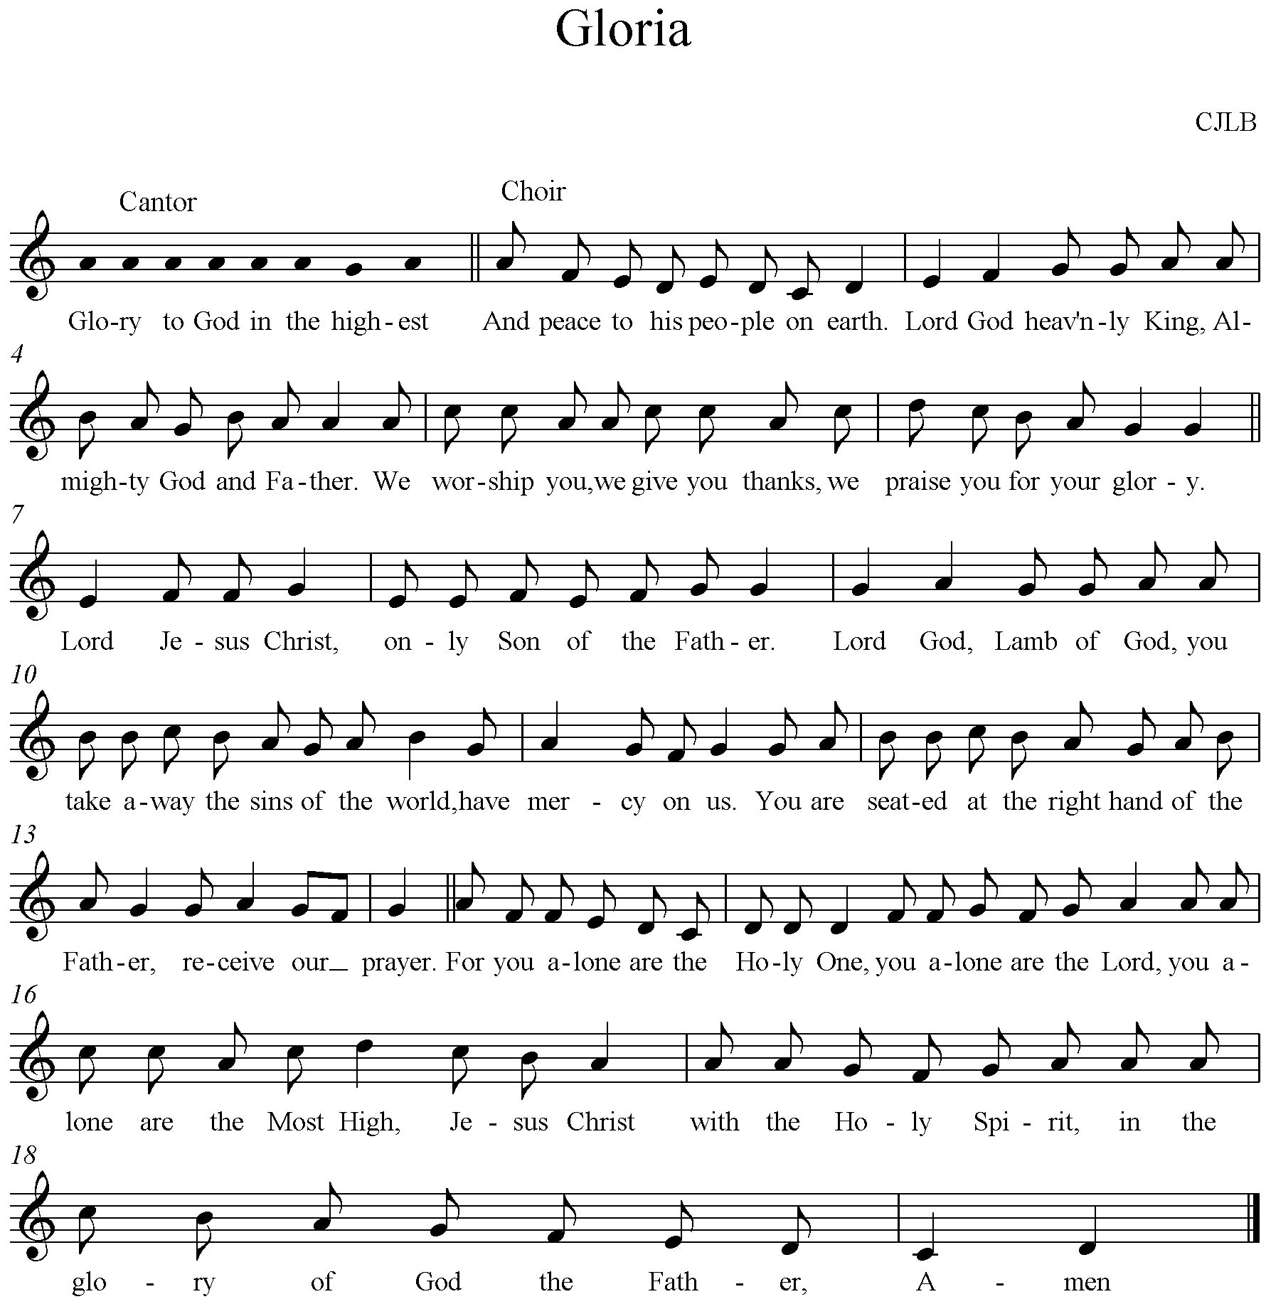

The Collect
The president introduces a period of silent prayer with the words 'Let us pray'.
The Collect is said.
Almighty God,
whose Son restored Mary Magdalene to health of mind and body
and called her to be a witness to his resurrection:
forgive our sins and heal us by your grace,
that we may serve you in the power of his risen life;
who is alive and reigns with you,
in the unity of the Holy Spirit,
one God, now and for ever.
All Amen.
The Liturgy of the Word
Old Testament Reading
Song of Solomon 3:1-4
At the end the reader says
This is the word of the Lord.
All Thanks be to God.
Psalm
Psalm 42:1-10
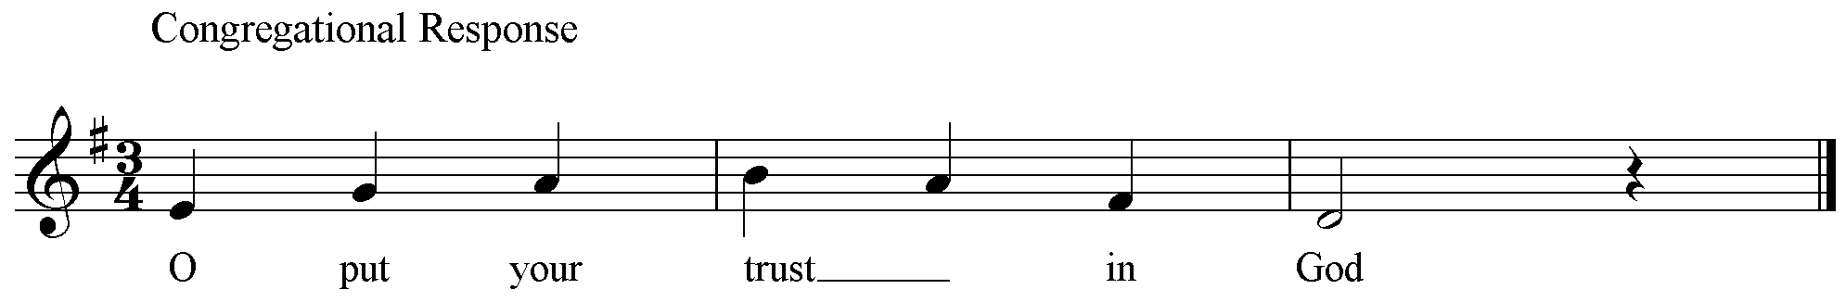
New Testament Reading
2 Corinthians 5:14-17
At the end the reader says
This is the word of the Lord.
All Thanks be to God.

Gospel Reading
John 20:1-2,11-18
This acclamation heralds the Gospel reading
Alleluia, alleluia.
Mary Magdalene announced to the disciples,
‘I have seen the Lord.’
All Alleluia.
When the Gospel is announced the reader says
Hear the Gospel of our Lord Jesus Christ according to N.
All Glory to you, O Lord.
At the end
This is the Gospel of the Lord.
All Praise to you, O Christ.
Sermon
The Creed
All We believe in one God,
the Father, the Almighty,
maker of heaven and earth,
of all that is,
seen and unseen.
We believe in one Lord, Jesus Christ,
the only Son of God,
eternally begotten of the Father,
God from God, Light from Light,
true God from true God,
begotten, not made,
of one Being with the Father;
through him all things were made.
For us and for our salvation he came down from heaven,
was incarnate from the Holy Spirit and the Virgin Mary
and was made man.
For our sake he was crucified under Pontius Pilate;
he suffered death and was buried.
On the third day he rose again
in accordance with the Scriptures;
he ascended into heaven
and is seated at the right hand of the Father.
He will come again in glory to judge the living and the dead,
and his kingdom will have no end.
We believe in the Holy Spirit,
the Lord, the giver of life,
who proceeds from the Father and the Son,
who with the Father and the Son is worshipped and glorified,
who has spoken through the prophets.
We believe in one holy catholic and apostolic Church.
We acknowledge one baptism for the forgiveness of sins.
We look for the resurrection of the dead,
and the life of the world to come.
Amen.
Prayers of Intercession
This response is be used
Lord, hear us.
All Lord, graciously hear us.
And at the end
Merciful Father,
All accept these prayers
for the sake of your Son,
our Saviour Jesus Christ.
Amen.

The Liturgy of the Sacrament
The Peace
The president introduces the Peace
God is love
and those who live in love live in God
and God lives in them.
The peace of the Lord be always with you
All and also with you.
Let us offer one another a sign of peace.
All may exchange a sign of peace.
This hymn is sung.
We Hail Thy Presence Glorious
We hail thy presence glorious,
O Christ our great High Priest,
o'er sin and death victorious,
at thy thanksgiving feast:
as thou art interceding
for us in heaven above,
thy church on earth is pleading
thy perfect work of love.
Through thee in every nation
thine own their hearts upraise,
offering one pure oblation,
one sacrifice of praise:
with thee in blest communion
the living and the dead
are joined in closest union,
one Body and one Head.

O living bread from heaven,
Jesu, our Saviour good,
who thine own self hast given
to be our souls' true food;
for us thy body broken
hung on the cross of shame:
this bread its hallowed token,
we break in thy dear name.
O stream of love unending,
poured from the one true vine,
with our weak nature blending
the strength of life divine;
our thankful faith confessing
in thy life-blood outpoured,
we drink this cup of blessing
and praise thy name, O Lord.
May we thy word believing,
thee through thy gifts receive,
that, thou within us living,
we all to God may live;
draw us from earth to heaven
till sin and sorrow cease,
forgiving and forgiven,
in love and joy and peace.
Words: Richard Godfrey Parsons(1882-1948)
Music: Offertorium; Michael Haydn (1737-1806)
Preparation of the Table
Taking of the Bread and Wine
During the singing of the hymn, the gifts of the people are gathered and presented. The altar is prepared and bread and wine are placed upon it. This prayer is said
Lord Jesus Christ,
grant that by the mystery of your body and blood
we may watch at your cross,
weep at your tomb
and witness to your resurrection;
for you are alive and reign,
now and for ever.
All Amen.
The Eucharistic Prayer
The Lord be with you (or) The Lord is here.
All and also with you. His Spirit is with us.
Lift up your hearts.
All We lift them to the Lord.
Let us give thanks to the Lord our God.
All It is right to give thanks and praise.
It is indeed right and good,
our duty and our salvation,
to praise you, the all-powerful Father, in every season,
and on this holy day to celebrate the glory of your saints.
In Mary Magdalene you kindled a fire of love for Christ,
whose word had set her free.
You gave her the courage of love
to follow him even to the cross.
Seeking her teacher after his death,
so great was her longing
that you made her the first to behold him
risen from the dead,
and the first to announce to the apostles
his new and glorious risen life.
Her words still ring throughout your Church,
to strengthen faith and encourage hope
in those who gather faithfully for prayer.
And so with her, and all the citizens of heaven,
we join our voices to acclaim your glory
in this their joyful hymn of praise:

Sanctus and Benedictus are sung
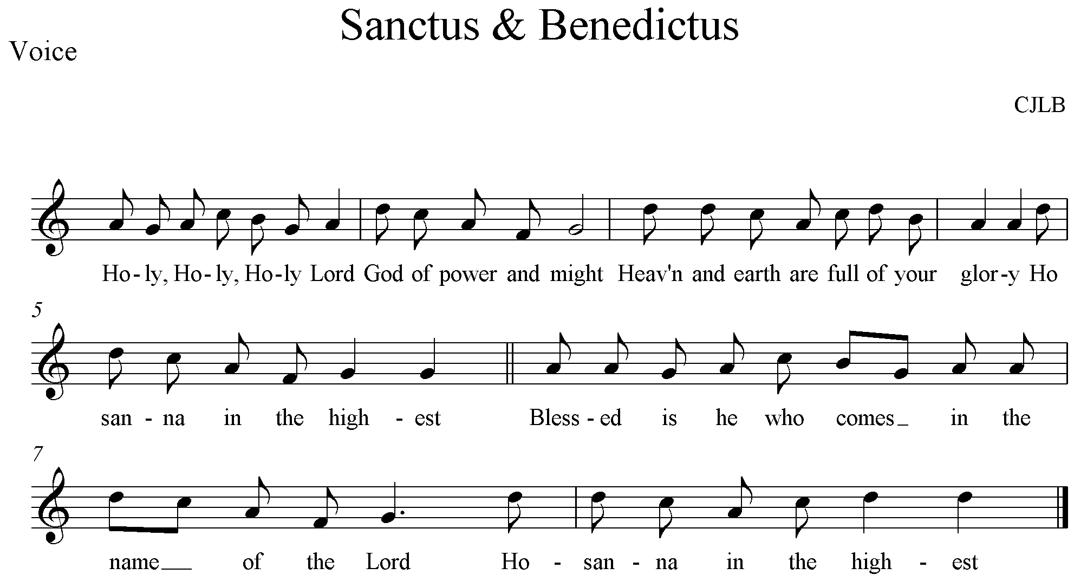
Lord, you are holy indeed, the source of all holiness;
grant that by the power of your Holy Spirit,
and according to your holy will,
these gifts of bread and wine
may be to us the body and blood of our Lord Jesus Christ;
who, in the same night that he was betrayed,
took bread and gave you thanks;
he broke it and gave it to his disciples, saying:
Take, eat; this is my body which is given for you;
do this in remembrance of me.
In the same way, after supper
he took the cup and gave you thanks;
he gave it to them, saying:
Drink this, all of you;
this is my blood of the new covenant,
which is shed for you and for many for the forgiveness of sins.
Do this, as often as you drink it,
in remembrance of me.

This acclamation is used
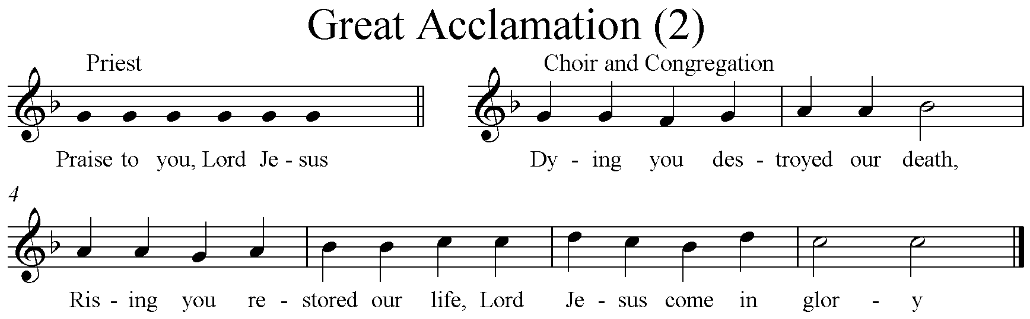
And so, Father, calling to mind his death on the cross,
his perfect sacrifice made once for the sins of the whole world;
rejoicing in his mighty resurrection and glorious ascension,
and looking for his coming in glory,
we celebrate this memorial of our redemption.
As we offer you this our sacrifice of praise and thanksgiving,
we bring before you this bread and this cup
and we thank you for counting us worthy
to stand in your presence and serve you.
Send the Holy Spirit on your people
and gather into one in your kingdom
all who share this one bread and one cup,
so that we, in the company of [N and] all the saints,
may praise and glorify you for ever,
through Jesus Christ our Lord;
by whom, and with whom, and in whom,
in the unity of the Holy Spirit,
all honour and glory be yours, almighty Father,
for ever and ever.
All Amen.
The Lord’s Prayer
Rejoicing in God’s new creation, let us pray with confidence as our Saviour has taught us
All Our Father, who art in heaven,
hallowed be thy name;
thy kingdom come;
thy will be done;
on earth as it is in heaven.
Give us this day our daily bread.
And forgive us our trespasses,
as we forgive those who trespass against us.
And lead us not into temptation;
but deliver us from evil.
For thine is the kingdom,
the power and the glory,
for ever and ever.
Amen.
Breaking of the Bread
The president breaks the consecrated bread.
We break this bread
to share in the body of Christ.
All Though we are many, we are one body,
because we all share in one bread.
Agnus Dei is sung
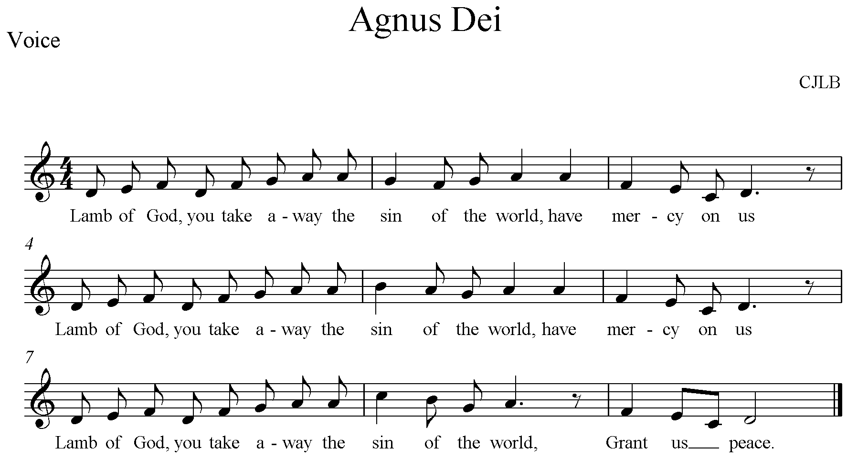
Giving of Communion
The president says
Draw near with faith.
Receive the body of our Lord Jesus Christ
which he gave for you,
and his blood which he shed for you.
Eat and drink
in remembrance that he died for you,
and feed on him in your hearts
by faith with thanksgiving.
The president and people receive communion. During the distribution anthems are sung
Prayer after Communion
Silence is kept.
God of life and love,
whose risen Son called Mary Magdalene by name
and sent her to tell of his resurrection to his apostles:
in your mercy, help us,
who have been united with him in this eucharist,
to proclaim the good news that he is alive and reigns, now and for ever.
All Amen.
All Father of all,
we give you thanks and praise,
that when we were still far off
you met us in your Son and brought us home.
Dying and living, he declared your love,
gave us grace, and opened the gate of glory.
May we who share Christ’s body live his risen life;
we who drink his cup bring life to others;
we whom the Spirit lights give light to the world.
Keep us firm in the hope you have set before us,
so we and all your children shall be free,
and the whole earth live to praise your name;
through Christ our Lord.
Amen.

The Dismissal
This hymn is sung. During the singing of this hymn, the ministers and people process to the west end of the Cathedral church.
O Thou Who Camest From Above
O thou who camest from above
the fire celestial to impart,
kindle a flame of sacred love
on the mean altar of my heart.
There let it for thy glory burn
with inextinguishable blaze,
and trembling to its source return
in humble prayer and fervent praise.
Jesus, confirm my heart's desire
to work and speak and think for thee;
still let me guard the holy fire
and still stir up the gift in me.
Ready for all thy perfect will,
my acts of faith and love repeat;
till death thy endless mercies seal,
and make the sacrifice complete.
Words: Charles Wesley (1707-1788)
Music: Hereford; S.S. Wesley (1810-1876)
Affirmation of Commitment
Those who are baptized are called to worship and serve God.
Will you continue in the apostles’ teaching and fellowship,
in the breaking of bread, and in the prayers?
All With the help of God, I will.
Will you persevere in resisting evil,
and, whenever you fall into sin, repent and return to the Lord?
All With the help of God, I will.
Will you proclaim by word and example
the good news of God in Christ?
All With the help of God, I will.
Will you seek and serve Christ in all people,
loving your neighbour as yourself?
All With the help of God, I will.
Will you acknowledge Christ’s authority over human society,
by prayer for the world and its leaders,
by defending the weak, and by seeking peace and justice?
All With the help of God, I will.
Eternal God, our beginning and our end,
preserve in your people the new life of baptism;
as Christ receives us on earth,
so may he guide us through the trials of this world
and enfold us in the joy of heaven,
where you live and reign,
one God for ever and ever.
All Amen.
The Blessing
May Christ, who makes saints of sinners,
who has transformed those we remember today,
raise and strengthen you that you may transform the world;
and the blessing of God almighty,
the Father, the Son, and the Holy Spirit,
be among you and remain with you always.
All Amen.
The Dismissal
Go in the peace of Christ.
All Thanks be to God.
The ministers and people depart.

Common Worship: Services and Prayers for the Church of England, material from which is included in this service, is copyright © The Archbishops’ Council 2000.
Common Worship: Festivals, material from which is included in this service, is copyright © The Archbishops’ Council 2008.
Common Worship: Christian Initiation, material from which is included in this service, is copyright © The Archbishops’ Council 2006.
The Eucharistic setting is the Missa Parochialis by Christopher Brook and is used by permission.
The responsorial Psalm setting is by Christopher Brook and is used by permission.
Hymn texts used in this service are in the Public Domain.

